**This needs PHP 5.6 OR PHP 7.0 Version**

**To Buy Latest version (August 2024)**

[**Whatsapp me: +918830756458**](https://wa.me/918830756458) **or visit** [**https://site.hubcity.info/cryptoexchange/contact-us/**](https://site.hubcity.info/cryptoexchange/contact-us/)

**Crypto Exchange Installation Documentation**

## Creating a new database

Before installing, you will need to create a new database. If you already know how to do this or have already created one, skip to the next step.

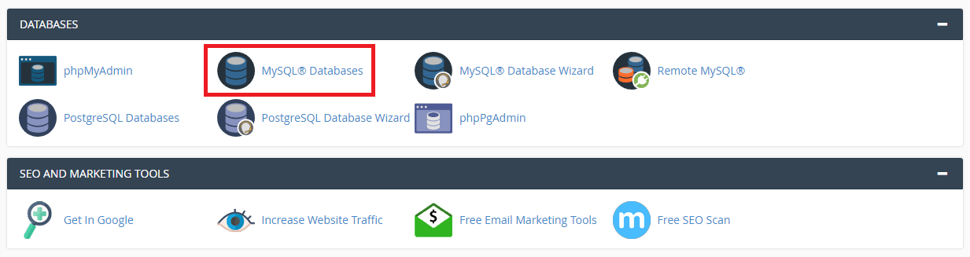

1. Create database with database name

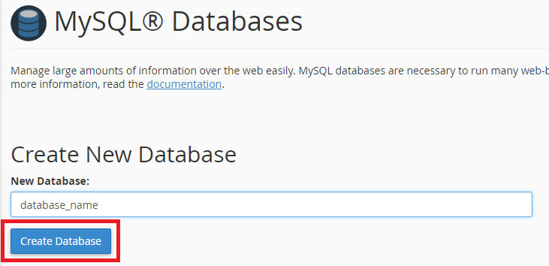

1. Add new user

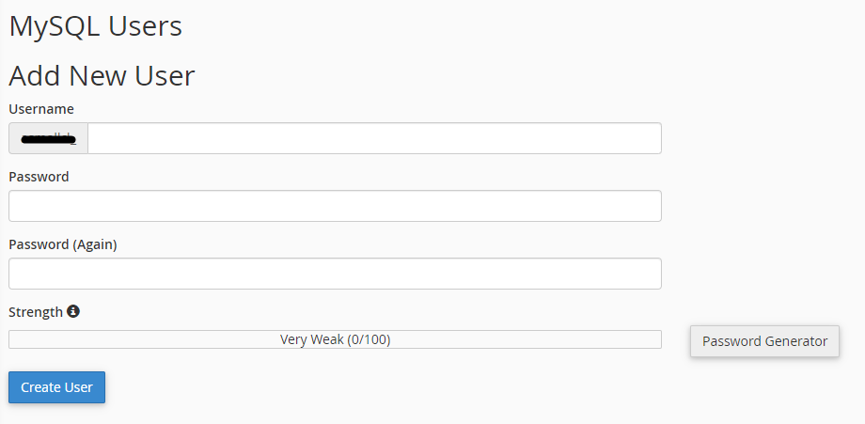

1. Add user to databese

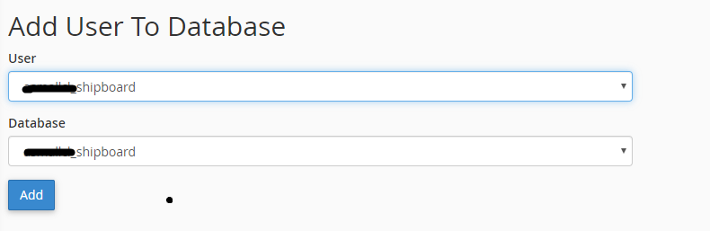

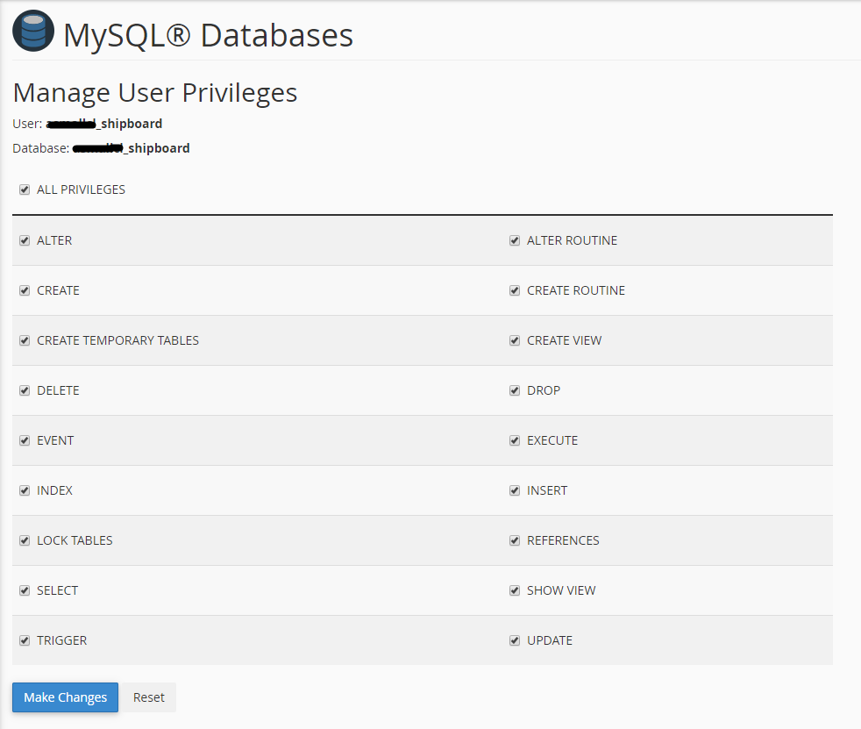

1. After creating a database. Open cPanel file manager. Upload project file (upload_files.zip) in the Main folder on the web root folder of your domain. This is generally called public_html, HTML, or examle.com, but depending on your server’s configuration.

**Note: -** If project file in zipped format, then extract the project file.

**Go to cPanel.**

1. Open phpMyAdmin and click on created database to import the database file. You will find database file in following folder (your_folder->upload_files->database->database.sql file).
2. Open application folder->config->config.php file.
3. Change base_url/base path on line number 25 with your domain name like

(http://example.com OR https://example.com).

1. Configure the database file(application->config-> database.php) with database username, password and database name. On line number 54, 55 and 56
2. Login your project with given credentials.

**Default User name and Password:**

**ADMIN PANEL**

**Link-:** https://yourdomain.com/admin/login

Username: admin

Password: admin

**USER PANEL**

**Link-:** https://yourdomain.com/login

Username: user

Password: 12345

**This needs PHP 5.6 OR PHP 7.0 Version**

**To Buy Latest version (August 2024)**

[**Whatsapp me: +918830756458**](https://wa.me/918830756458) **or visit** [**https://site.hubcity.info/cryptoexchange/contact-us/**](https://site.hubcity.info/cryptoexchange/contact-us/)